|  |  |
| --- | --- |
| **Customer request number** |  |
| **Customer request description** |  |

Contents

1. DOCUMENT TRACKER 4

2. STAKEHOLDER DETAILS 5

2.1 Customer Stakeholder Information 5

2.2 Group IT Information 6

3. GLOSSARY OF TERMS / DEFINITIONS 7

4. ABBREVIATIONS 7

5. REASON FOR THE REQUIREMENT 8

5.1 Current business challenges / issues that need to be addressed 8

5.2 High level gaps between the “As-Is” and “To-Be” state 8

6. AS IS AND TO BE BUSINESS PROCESS ACTIVITY MAPPING 8

6.1 As-is business process 8

6.2 To-be business process 8

7. BUSINESS REQUIREMENTS 9

7.1 High level Requirements 9

7.2 Detailed requirements and Business rules 10

7.3 Data flow diagram / Context diagram 11

7.4 High level reporting requirements 12

7.5 Detailed reporting requirements 12

8. INFORMATION / DATA REQUIREMENTS 13

9. USER INTERFACE REQUIREMENTS 14

10. SYSTEM INTEGRATION REQUIREMENTS 14

11. ACCESS REQUIREMENTS 14

12. ARCHIVING REQUIREMENTS (not mandatory for change requests) 15

13. DISASTER RECOVERY REQUIREMENTS (not mandatory for change requests) 15

14. BUSINESS CONTINUITY REQUIREMENTS (not mandatory for change requests) 15

15. LEGAL REQUIREMENTS 15

16. INTELLECTUAL PROPERTY 15

17. PRECONDITIONS 16

18. REFERENCES 16

19. DOCUMENT ACKNOWLEDGEMENT 17

20. DOCUMENT APPROVAL 18

21. ANNEXURE 1 (not included in the BRS development timeline and is not part of Quality Assurance or Sign-off) 19

22. ANNEXURE 2 (not included in the BRS development timeline and is not part of Quality Assurance or Sign-off)) 20

# DOCUMENT TRACKER

|  |  |  |
| --- | --- | --- |
| **Date** | **Author Name** | **Changes (section changed, page number, from what to what)** |
| dd-mm-yyyy |  | Initial draft |
|  |  |  |
|  |  |  |

**NOTE: Any additional information may be added to the BRS.**

Instructions:

* All sections as defined in the template need to be completed. If a section is not completed, a valid reason needs to be provided. For example, some sections are not required for change requests. If the quality assurer is in agreement with the motivation the section may be removed for that specific request.
* All business requirement specifications must subscribe to the quality assurance process.
* Requirements must be defined in a “SMART” way:
* S – Simple
* M – Measurable
* A – Achievable
* R – Realistic
* T – Timely

Smart requirement ensures there is clarity in requirements and therefore less dispute with stakeholders. That translates to faster sign off or turnaround time for the requirements. This also gives much better clarity to the developers.

* The detailed business requirements need to be documented in table format as indicated in the template, not in paragraphs.
* Any additional sections can be added to the template. However, from a quality assurance perspective only the standard contents will be formally reviewed.
* A business analysis activity plan needs to be compiled and monitored by the person compiling the business requirement document to track the progress of the requirements elicitation, analysis and documentation.
* All text that appears in red are guidelines and needs to be removed prior to the document been signed.
* Remember to update the table.
* NOTE: All text that appears in blue are hints and needs to be removed prior to the document been signed.

STAKEHOLDER DETAILS

Customer Stakeholder Information

| **Name** | **Department & Division** | **Role / Expertise** | **Contact Info** | **Participation** |
| --- | --- | --- | --- | --- |
| <insert name here> |  | Business Requestor(s) |  | For example: Requested SME to form part of analysis |
| <insert name here> |  | Business Senior Manager(s) |  | For example: Only wants to participate after BRS draft ready |
| <insert name here> |  | Business Subject Matter Expert |  | For example: To participate in all workshops and review draft BRS |
| <insert name here> |  | Business Executive / manager(s) area who will receive and use the outputs of this project |  |  |
| <insert name here> |  | Business Process Owner |  | For example: Only wants to participate after BRS draft ready |
| **If BRS is being developed for a project the following information needs to be defined:** | | | | |
| <insert name here> |  | Business Sponsor/s |  |  |

☺ Hint: There is sometimes a difference between a contributor and a signatory.

☺ Hint: Determine who the stakeholders are that will approve the business requirements specification. This is important as they will need to assist if there are conflicting requirements.

Group IT Information

Define who in Group IT will contribute to the business requirements specification.

Remove roles / add roles as required.

| **Name** | **Department & Division** | **Role / Expertise** | **Contact Info** | **Participation** |
| --- | --- | --- | --- | --- |
| <insert name here> | Group IT Business Relationship Manager  Business Solutions and Development Services | IT Business Relationship Manager |  | Review process (but not limited to) |
| <insert name here> | Group IT Portfolio Manager  Business Solutions and Development Services | IT Portfolio Manager |  | Review process (but not limited to) |
| <insert name here> | Group IT Architect (for all requests except change requests)  Business Solutions and Development Services | IT Architect |  | Review process (but not limited to) |
| <insert name here> | Group IT Application Operations Advisor (if applicable)  Application Operations | IT Application Operations Advisor |  | To participate in all workshops and review draft BRS |
| <insert name here> | Group IT Application Operations Manager (if applicable)  Application Operations | IT Application Operations Manager |  | Review process (but not limited to) |

GLOSSARY OF TERMS / DEFINITIONS

Explain key concepts used in document.

| **Term** | **Definition** |
| --- | --- |
| Business Continuity | Business continuity encompasses planning and preparation to ensure that an organization can continue to operate in case of serious incidents or disasters and is able to recover to an operational state within a reasonably short period. |
| Business Requirements Specification | Business requirements specification is the eliciting, analysing and documenting of business requirements early in the development cycle to guide the design of the solution. |
| Business Rule | A business rule is a rule that defines or constrains some aspect of business and always resolves to either true or false. Business rules are intended to assert business structure or to control or influence the behaviour of the business.  Business rules describe the operations, definitions and constraints that apply to an organization. Business rules can apply to people, processes, corporate behaviour and computing systems in an organization, and are put in place to help the organization achieve its goals. |
| Disaster Recovery /  Disaster Recovery Plan | A disaster recovery plan (DRP) is a documented process or set of procedures to recover and protect a business IT infrastructure in the event of a disaster. Such a plan, ordinarily documented in written form, specifies procedures an organization is to follow in the event of a disaster. It is "a comprehensive statement of consistent actions to be taken before, during and after a disaster". |
| Process | Set of activities that describe how an activity is executed. |
| System | An organized, purposeful structure that consists of interrelated and interdependent elements (components, entities, factors, members, parts etc.). These elements continually influence one another (directly or indirectly) to maintain their activity and the existence of the system, in order to achieve the goal of the system |
| Start your list from here | Do not remove previous information |

ABBREVIATIONS

Provide description for all abbreviations used in document (add to existing table, remove what is not applicable and sort alphabetically).

| **Abbreviation** | **Description** |
| --- | --- |
| ARIS | Architecture of Integrated Information Systems |
| BCP | Business Continuity Plan |
| BRS | Business Requirements Specification |
| CR | Change Request |
| DR | Disaster Recovery |
| GIT | Group Information Technology Division, also referred to as Group IT |
| IT | Information Technology |
| KPA | Key Performance Area |
| KPI | Key Performance Indicator |
| PCM | Process Control Manual |

# REASON FOR THE REQUIREMENT

Current business challenges / issues that need to be addressed

This section needs to be populated with the understanding that anyone reading through the document will understand the current challenges / issues.

☺ Hint: This information is captured on the e-form by the customer and can be used as the base entry (if correct).

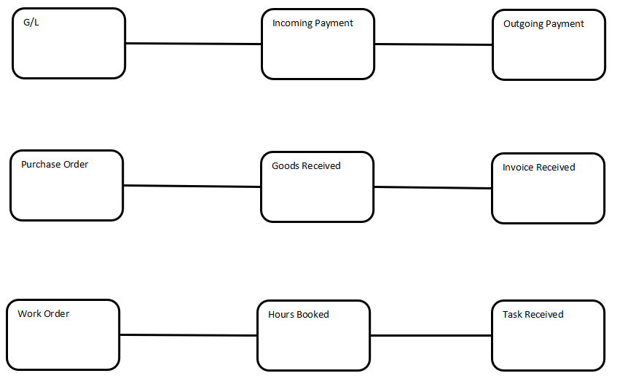

High level gaps between the “As-Is” and “To-Be” state

| **As Is Statement** | **To Be Statement** | **Therefore the high level gap is:** |
| --- | --- | --- |
|  |  |  |
|  |  |  |
|  |  |  |

AS IS AND TO BE BUSINESS PROCESS ACTIVITY MAPPING

As-is business process

Identify the PCM and list the PCM activities that are impacted:

Use the ARIS model and indicate the impacted activities.

To-be business process

Define any new business processes that will be a result of this requirement:

If no change in business process, state that.

☺ Hint: Suggest you do this section after you have defined the formal business requirements.

Note: Changes to the business process / initiation of new business processes are the responsibility of the business to initiate.

Should this be identified during the requirements gathering session please advise the relevant Business Process Manager.

BUSINESS REQUIREMENTS

High level Requirements

Transform the high level gap analysis into an executive summary. This will ensure that the information is consistent and accurate.

xxxxxxxxxxxxx

According to the requestor the high level requirements support the following *strategic objective/s*:

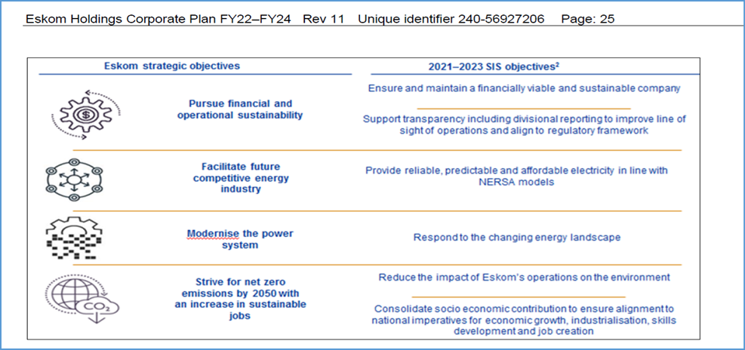

This information is to be copied from the customer request form.

The requestor to provide evidence to support the strategic objective selection either through their mandate, business plan or business unit operational plan.

Detailed requirements and Business rules

Define the detailed business requirements in number form ensuring that the functionality is sorted and described in functionality groupings.

M**ust be captured in the table format.**

☺ Hint: The difference between a business requirement and a business rule:

* Business requirement – defines the what.
* Business rule – defines how a specific functional requirement must be calculated as demonstrated above.
* Info - the technical functional specification will then define how the requirement and rule must be designed in a system.

☺ Hint: Refer to the relevant PCM to confirm if no gaps (if PCM available).

| **Functionality grouping** | **BRS Number** | **Functionality** | **Business Rule No and Description** | **Weight** |
| --- | --- | --- | --- | --- |
| Example:  Addition of HR data | BRS 1 | Ability to manually add the person’s name and surname either by selecting from a prescribed list or entering text together with a user populated date. (Role: HR data capturer). |  | <Refer to rating table; no other rating to be used> |
|  |  |  |  |  |

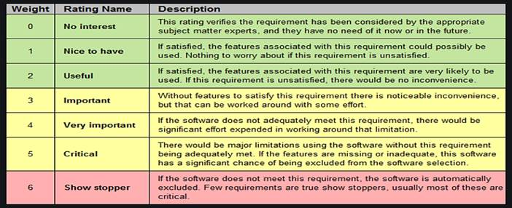

Data flow diagram / Context diagram

This diagram is used to assist in understanding the scope of the business requirement.

The diagram must indicate the area of:-

* Analysis area of study
  + Represented by a circle in the middle (e.g. Automated Maintenance Scheduling Requirement)
  + Conceptually includes more than the actual requirement
* Sends / receives information
  + Represented by rectangular boxes
  + Sends information to and receive information from analysis area of study
  + Acts independently
* Data flows
  + Represented by arrows between send / receive and the analysis area of study
  + Labelled to identify the data exchanged

Here are some examples that have been downloaded for ease of reference (increase zoom to read):

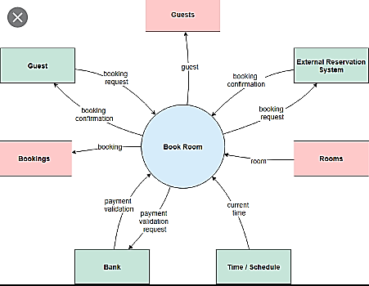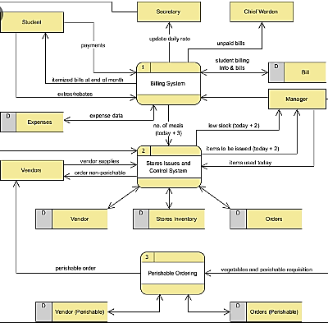

By looking at the diagram the scope of the business requirements must be able to be defined.

High level reporting requirements

Table format must be used.

|  |  |  |  |  |  |
| --- | --- | --- | --- | --- | --- |
| **Nr** | **Report Name** | **Functionality** | **Define business objective being supported** | **Define KPI being measured** | **Weight (refer to rating table)** |
| HLREP1 |  |  |  |  |  |
| HLREP2 |  |  |  |  |  |
|  |  |  |  |  |  |

Note: Ensure that you aware of how the information is currently being reported on and that decisions will be made using the report.

Detailed reporting requirements

Note: For Analytics related requests this section must be completed together with both the Analytics team and the business:

Hint: Confirm if any KPI’s are documented in the relevant PCM and if documented, are they KPI’s to be reported on or not

| **Nr** | **KPI** | **Name of Measure** | **Measure Specific Doc Nr** | **Business Definition of Measure** | **Business calculation (how)** | **Business Rule** | **Functionality** | **Priority/ Phasing** | **Frequency** | **UOM (Unit of Measure)** | **Strategic Objective** | **KPA** | **Is data available for reports? Indicate Y/N and define what the data sources are/will be** |
| --- | --- | --- | --- | --- | --- | --- | --- | --- | --- | --- | --- | --- | --- |
| DETREP1 |  |  |  |  |  |  |  |  |  |  |  |  |  |
| DETREP2 |  |  |  |  |  |  |  |  |  |  |  |  |

INFORMATION / DATA REQUIREMENTS

This section must be completed; it may not be deleted.

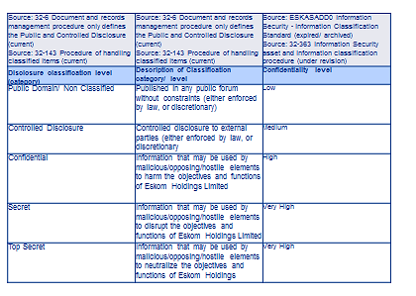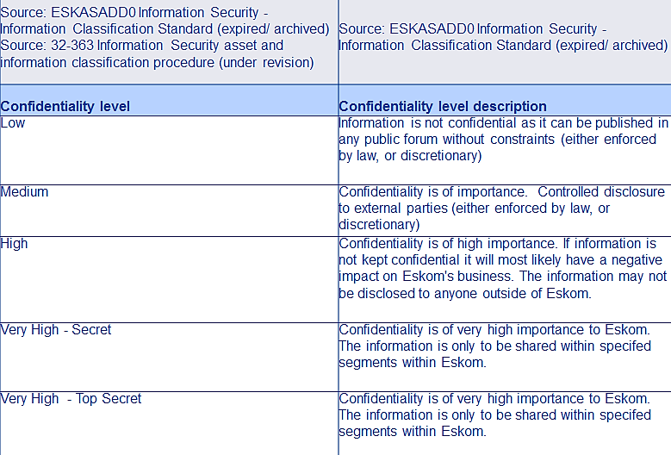

| **Classification of data / information** | **Data / Information type** | **Confidentiality of information (refer to previous page for quick reference)** | **Confidentiality level of information (refer to previous page for quick reference)** | **Availability of data** | **Migration of data** |
| --- | --- | --- | --- | --- | --- |
| Select from the following list:   * Use & re-use (information flow)/ usage patterns * Information security/ risk associated with the disclosure * Document and record management * Governance & legislative requirements * Life cycle stages * Add own type if not one of the above | For example, financial, HR, GIS etc. | Select from the following list:   * Public domain / non classified * Controlled disclosure * Confidential * Secret * Top secret | Select from the following list:   * Low * Medium * High * Very high – secret * Very high – top secret | Refer to the disaster recovery section, the business will advise how long they can be without data) to source the information | Is migration of data required? If so, describe the source of data. |

If any data is currently not available the business needs to define the plans they have in place to ensure how and when the data will be available.

| **BRS Number** | **Gap** | **Owner of data** | **Business plan to source data** |
| --- | --- | --- | --- |
|  |  |  |  |

USER INTERFACE REQUIREMENTS

|  |  |  |
| --- | --- | --- |
| **BRS Number** | **Functionality** | **Type of user interface** |
| UI1 | Ability to manually add the person’s name and surname either by selecting from a prescribed list or entering text. (Role: HR data capturer). | Text  Similar to Zenzele |
|  |  |  |

SYSTEM INTEGRATION REQUIREMENTS

| **BRS Number** | **Functionality** | **Impacted Systems (if known)** | **Sending System Owner (if known)** | **Receiving System Owner (if known)** | **What information needs to be integrated** |
| --- | --- | --- | --- | --- | --- |
| SI1 | Ability to manually add the person’s name and surname either by selecting from a prescribed list or entering text together with a user populated date. (Role: HR data capturer). | HR  Recruiting | Recruiting - VV Sure | SAP HR –  AN Other | Recruiting to send to SAP HR:  Name and Surname  Date  SAP HR to send to Recruiting:  Unique Number  Data to be refreshed every 2 hours. |
|  |  |  |  |  |  |

Note: Normally not applicable for Change Requests.

Note: Normally not done with customer. Internal GIT activity if known.

Note: Functional Requirements Specification document needs to contain this type of detail.

ACCESS REQUIREMENTS

Define different types of access roles that are required (if known).

|  |  |  |
| --- | --- | --- |
| **BRS Number** | **Role** | **Define different types of access and**  **what permissions that role has** |
| These requirements have their own  unique BRS number | Write Access | HR data capturer only able to add person name and surname.  HR supervisor should be able to add person name and surname but only if reason provided. |

Note: Refer to Information Security policy for assistance

ARCHIVING REQUIREMENTS (not mandatory for change requests)

State the retention / archiving period required for the data/information.

| **Retention Period** |
| --- |
| For example:  As per the governmental requirement of being able to access personnel information for a period of up to 20 years after deceased date. |

DISASTER RECOVERY REQUIREMENTS (not mandatory for change requests)

Define the high-level disaster recovery requirements.

| **Data loss** | **Time to recover** |
| --- | --- |
| Define how long the business can be without the facility to capture data. For example, sometimes month end is the only critical period. | Define how long the business can operate without a system (consecutive days).  See Business Continuity planning information. |

BUSINESS CONTINUITY REQUIREMENTS (not mandatory for change requests)

|  |  |
| --- | --- |
| Business continuity plan exists | Y/N |
| Name of BCP |  |
| Name of BCP owner |  |
| If BCP does not exist, what plans are in place from a customer view to define a BCP |  |
| If BCP needs to change, what plans are in place from a customer view to update the BCP |  |

LEGAL REQUIREMENTS

| **BRS Number** | **Functionality** | **Legal Requirement.**  **Response Y/N**  **If Yes, provide legal document number / clauses** |
| --- | --- | --- |
| Example  BRS 1 | Ability to manually add the person’s name and surname either by selecting from a prescribed list or entering text together with a user populated date. (Role: HR data capturer). | Yes  As per the governmental requirement of being able to access personnel information for a period of up to 20 years after deceased date. |

INTELLECTUAL PROPERTY

All intellectual property (requirements) belongs to Eskom.

This statement must not be removed from the BRS.

PRECONDITIONS

That which needs to be in place in order for this business requirement to be implemented / achieved including soft issues. An example can be data migration, clean up of data etc.

| **Unique identifier number** | **Business Activities** | **Processes** | **Projects (IT and Business)** | **Technology (if known)** | **Other (define)** |
| --- | --- | --- | --- | --- | --- |
| PD1 | Clean up of HR Data | PCM’s support the requirement. | None | Existing system | Precondition |
|  |  |  |  |  |  |

REFERENCES

The following documents have been referenced or used to compile this Business Requirements Specification including Process Control Manuals.

| **Number** | **Name** | **Location** |
| --- | --- | --- |
|  |  |  |
|  |  |  |

DOCUMENT ACKNOWLEDGEMENT

By signing this document, the people listed record their agreement on the contents of this document.

*Disclaimer: Formal governance processes will need to be followed prior to obtaining approval for the implementation of the business requirements specification and the initiation of a project plan.*

Remove roles that are not applicable before obtaining sign-off and the words “if applicable”.

| **Name** | **Role** | **Signature** | **Date** |
| --- | --- | --- | --- |
| <insert name here> | Group IT Business Process Management Business Analyst  Business Solutions and Development Services |  |  |
| <insert name here> | Business Requestor |  |  |
| <insert name here> | Business Subject Matter Expert x n |  |  |
| <insert name here> | Group IT Application Operations Advisor (if applicable)  Application Operations |  |  |
| <insert name here> | Group IT Analytics Analyst / Advisor (only for analytics related requests)  Business Solutions and Development Services |  |  |

DOCUMENT APPROVAL

By signing this document, the people listed record their approval on the contents of this document.

*Disclaimer: Formal governance processes will need to be followed prior to obtaining approval for the implementation of the business requirements specification and the initiation of a project plan.*

Remove roles that are not applicable before obtaining sign-off and the words “if applicable”.

| **Name** | **Role** | **Signature** | **Date** |
| --- | --- | --- | --- |
| <insert name here> | Group IT Business Process Management Manager  Business Solutions and Development Services  Part of the review process |  |  |
| <insert name here> | Group IT Business Relationship Manager  Business Solutions and Development Services  Part of the review process |  |  |
| <insert name here> | Group IT Application Operations (if applicable)  Application Operations  Part of the review process |  |  |
| <insert name here> | Group IT Enterprise Architecture (for all requests except change requests)  Business Solutions and Development Services  The architect acknowledges that there is enough information to proceed to the next step in the process (statement of architecture work) as per the services delivered by BPM. |  |  |
| <insert name here> | Group IT Portfolio Manager  Business Solutions and Development Services  Part of the review process |  |  |
| <insert name here> | Senior Business Manager / Business Sponsor |  |  |

ANNEXURE 1 (not included in the BRS development timeline and is not part of Quality Assurance or Sign-off)

**CHANGE REQUEST COSTING**

Delete the annexure if a non-change BRS.

This section is completed by Application Operations and is the overall responsibility of the Business Relationship Manager to monitor.

The Business Analyst can initiate the request to ITSO for the information but the responsibility to track the progress resides with the BRM.

| **Description** | **Hours** | **Rand value** |
| --- | --- | --- |
| ***Number of development man-hours & cost per skill level***: |  |  |
| Define quantity of personnel here |  |  |
| For example Senior Developer x 1 | 400 | R 400 000 |
|  |  |  |
| ***Number of testing manhours & cost per skill level:*** |  |  |
| Define quantity of personnel here |  |  |
| For example Junior Testers x 2 | 220 | R 220 000 |
|  |  |  |
| License costing |  | 0 |
| Vendor costing |  | 0 |
| Any other costing information |  | 0 |
|  |  |  |
| **TOTAL APPROXIMATE COST** | - | R 620 000 |

ANNEXURE 2 (not included in the BRS development timeline and is not part of Quality Assurance or Sign-off))

**CHANGE REQUEST OPTION**

Delete the annexure if a non-change BRS.

This section is completed by Application Operations and is the overall responsibility of the Business Relationship Manager to monitor.

The Business Analyst can initiate the request to ITSO for the information but the responsibility to track the progress resides with the BRM.

|  |  |
| --- | --- |
| Description |  |
| Critical knowledge /skills /enabling factors required to provide a successful delivery |  |
| Option Risks | <Include risks of successful delivery for the option> |
| Advantages |  |
| Disadvantages |  |
| Fit to need: | <percentage fit that the option will have to the need/requirements of the business> |
| Estimated implementation duration: | <Start and end date> |